Design of a Dual-Band Flexible Microstrip Patch Antenna on Transparent Substrate for IoT and ISM Band Applications

Ayush Mukherjee   
Electronics and Communication EngineeringInstitute of Engineering and ManagementKolkata, India  
supriyamukherjee1979@gmail.com

Satavisha Dutta  
Electronics and Communication EngineeringInstitute of Engineering and ManagementKolkata, India  
satavishadutta0@gmail.com

Gobinda Sen   
Electronics and Communication EngineeringInstitute of Engineering and ManagementKolkata, India  
gobinda.sen@iem.edu.in

*Abstract*—The presented work follows a transparent and flexible dual band microstrip-fed patch antenna that can function in both IoT and ISM Band applications. The radiating parts of the antenna consist of two inverted L-shaped patches with two slots cut on it fed by a microstrip feedline along with a rectangular stub above it while the ground plane is modified to achieve dual-band functionality. The novelty of the presented work is showcased by the use of low-cost and flexible Polyethylene terephthalate (PET) material, a thermoplastic semi-crystalline polymer of the polyester group has been used as the substrate with dielectric constant taken as 3.6 and a thickness of 1.6 mm, to achieve optical transparency. The antenna is capable of operating within the frequency bands of 3.66 GHz to 5.88 GHz with an impedance bandwidth of 0.26 GHz over frequencies of 3.54 GHz to 3.80 GHz and 2.81 GHz over 5.30 GHz to 8.11 GHz which lies in the IoT and ISM bands. The proposed design of the antenna is simulated using the Ansys HFSS (High Frequency Structure Simulator) software which runs on finite element method (FEM) technique.

Keywords—Dual band, optically transparent antenna, inverted L-shaped, Polyethylene terephthalate (PET), IoT and ISM applications.

# Introduction

The modernization of technologies in the 21st century led to engineering marvels in the design and fabrication of antennas which are being used for Internet of Things (IoT) as well as for Industrial, Scientific and Medical (ISM) bands [1]. The evolution of the antennas are taking place rapidly to accelerate the growth of the industries in relation to the frequencies they resonate in, thus procuring the need of suitable communication systems for error-free data transmission [2].

Transparent electronics have gained an immense popularity these days which are implemented seamlessly across various domains of modern scientific and industrial applications due to their easy integration with the existing communication technologies. A transparent antenna is an antenna which is designed in such a way that is invisible or almost slightly prominent when placed or integrated into transparent materials such as glass or plastic. These antennas are used in areas where the function of traditional design antennas are non-workable and where design factors are considered [3]. Conversely, compared to other conventional antennas, flexible antennas are well-regarded because of their compatible integration with curved or irregular surfaces, thus finding applications in wide range of substantial communication technologies [4]. Thus the implementation of flexible antenna with transparent substrate finds applications in wide range of wearable technologies because of their almost invisible appearance as well as new aspects of broader features which were previously unimaginable [5]. Transparent electronic systems have enabled seamless discrete implementations of the technological systems. So it will be necessary to upgrade the antennas for modern scientific uses as the size of the gadgets decreases, there will be necessities for antennas that can support huge capacities as well as compatible sizes [6]. In this way, transparent antennas can replace the traditional ones and thus introduce novel features in their usages which were deemed impossible before.

In [7], J. Kaur *et al* proposed a dual-band microstrip fed patch antenna structure with two inverted-L shaped patches along with FR-4 epoxy substrate on a defective ground structure. However, the use of flame retardant FR-4 epoxy substrate makes the design unsuitable for wearable applications. Hence in this work, a new design is proposed using a transparent Polyethylene terephthalate (PET) substrate. Along with the radiating parts of the antenna which involve the patches additionally a rectangular stub is placed above the patches and two slots of equal dimensions have been cut on the patches. The usage of PET substance as material for the substrate supported to the transparency and wearable operability of the antenna. The proposed design is shown to resonate in the band of frequencies from 3.66 GHz to 5.88 GHz with return losses less than -10 dB and gain of 5.24 dB at 5.25 GHz and an impedance bandwidth of 0.26 GHz from 3.54 GHz to 3.80 GHz and 2.81 GHz from 5.30 GHz to 8.11 GHz. Thus this design can operate in the IoT and ISM frequency bands offering a large bandwidth. The following sections outline the comprehensive layout of the proposed structure and an-depth study of the simulated results such as reflection coefficient, radiation pattern, gain and surface current distribution.

# antenna design

The proposed work consists of a simple monopole antenna which involves two inverted-L shaped patches fed by a microstrip line of length (L1) = 5 mm. The longer strips connecting the patches to the feedline are of length (L2) = 33.5 mm and of thickness (a) = 2 mm. The arms of both the patches are of length (L3) = 11.7 mm and of width (W3) = 23 mm and are separated by a gap (b) of 2 mm. The 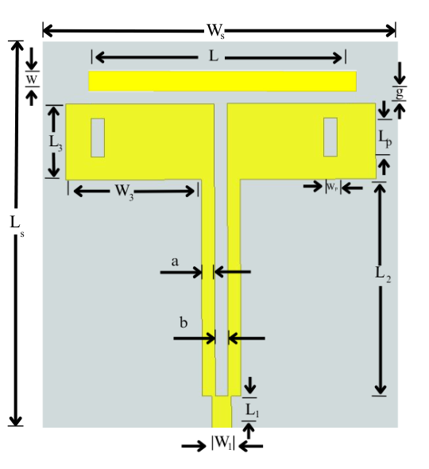PET material used for the substrate used has a dielectric constant (ε) = 3.6, loss tangent = 0.02 [8] and of thickness (Hs) = 1.6 mm. Additionally, one rectangular stub of length (L) = 40 mm and of thickness (W) = 30 mm has been added at a gap (g) of 0.1 mm from the patches along with two slots of equal dimensions (Lp × Wp) = 6 × 2 mm2 have been cut on the patches to attain better results of dual band frequencies for higher bandwidth. The following parameters shown in Table I are used to design the proposed structure.

1. DIMENSIONS OF THE PROPOSED ANTENNA

| ***Parameter*** | ***Value (mm)*** | ***Parameter*** | ***Value (mm)*** |
| --- | --- | --- | --- |
| L1 | 5 | Wp | 2 |
| W1 | 3 | Ls | 70 |
| L2 | 33.5 | Ws | 60 |
| W2 | 2 | Hs | 1.6 |
| L3 | 11.7 | Lg1 | 8 |
| W3 | 23 | Wg1 | 31 |
| L | 40 | a | 2 |
| W | 3 | b | 2 |
| Lp | 6 | g | 0.1 |

The addition of the rectangular stub at the distance of 0.1 mm from the patches have an impacted wideband effect on the design thus giving better gain for the results. It has been also observed that the performance of the antenna is impacted by the cutting of two slots on the patches, thus offering sufficient amount of reflection coefficients for the desired resonating frequencies in the applicable IoT and ISM bands. Also the thickness of the PET substrate which is taken as 1.6 mm not only makes the design transparent, but also makes it flexible thus offering high range of modern technology applications. The defective ground structure of the antenna with the modified design also contribute to the simulated results. The complete geometry of the proposed work have been shown in Fig. 1.

## 

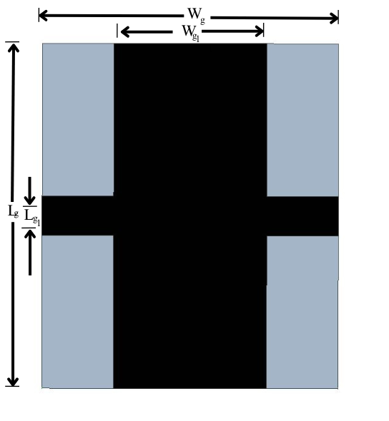 (a)

(b)  
  
 Fig. 1. a) Top view of the proposed antenna and b) Back view  
 showing the modified ground structure.

# results and analysis

The results of the design of the antenna are observed by the simulation of the structure on Ansys High Frequency Structure Simulator (HFSS) software which uses the Finite Element Method (FEM) principle to realize the effect of the design parameters.

## Reflection Coefficient

The proposed design is shown to resonate at frequencies around 3.66 GHz and 5.88 GHz offering reflection coefficients of around -20.25 dB and -32.46 dB. Thus this design resonates at dual band frequencies with a common operating impedance bandwidth of 0.26 GHz and 2.81 GHz over a span of 3.54 GHz to 3.80 GHz and 5.30 GHz to 8.11 GHz respectively in the IoT and ISM bands, which is in agreement with the resonating frequencies. This result shows an improvement from the standard FR4-epoxy as substrate. The simulated reflection coefficient of the antenna is shown in Fig. 2.

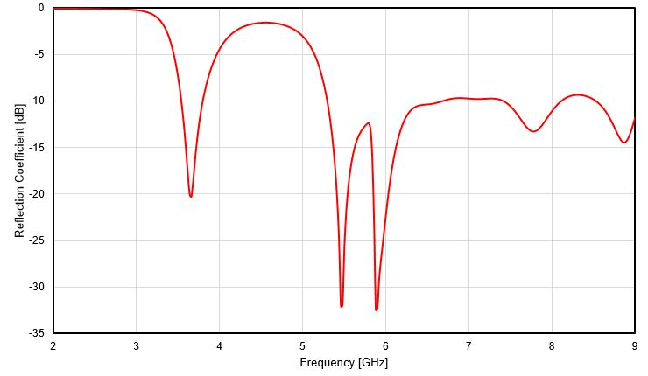

Fig. 2. Reflection coefficient of the proposed design.

## Radiation Pattern and Gain

The directional distribution of the total energy radiated by the antenna is depicted by the radiation pattern. The proposed design offers a gain of 5.24 dB at the frequency of 5.25 GHz. The simulated radiation pattern shown by the 2D polar plots for the E-plane (Phi = 0°) and H-plane (Phi = 90°) at 3.66 GHz and 5.88 GHz are given in the Fig. 3.

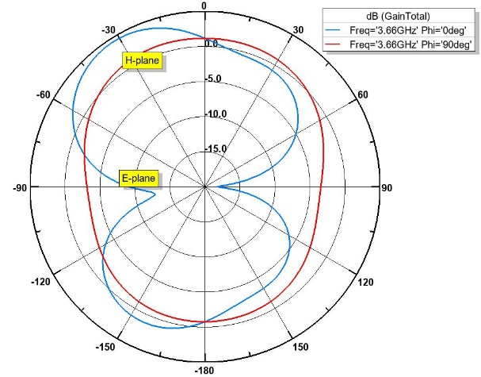

(a)

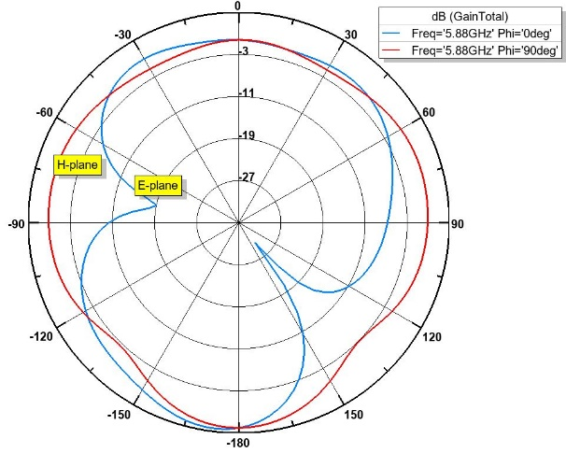

(b)

Fig. 3. Radiation pattern of the antenna at (a) 3.66 GHz, and (b) 5.88 GHz.

## Surface Current Distribution

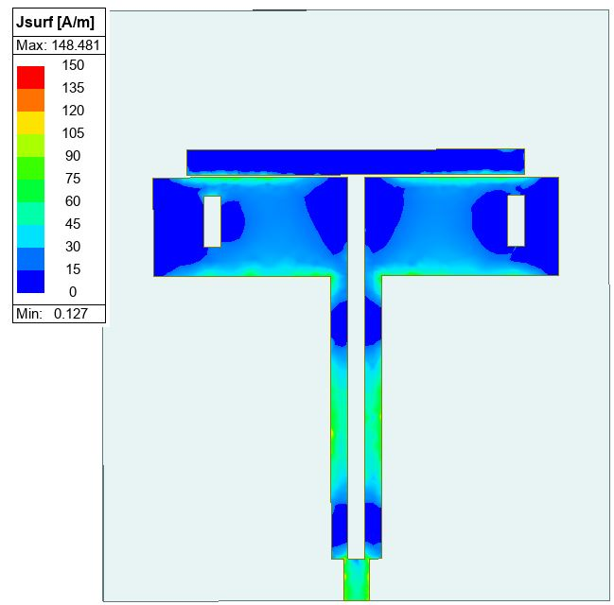Using the surface current distribution on the patches and the rectangular stub, which refers to the variation of electric current across it, the float of current for a specific resonant frequency can be calculated. The surface current distribution on the patches and the stub for the two bands of frequencies for 3.66 GHz and 5.88 GHz are shown in Fig. 5.

(a)

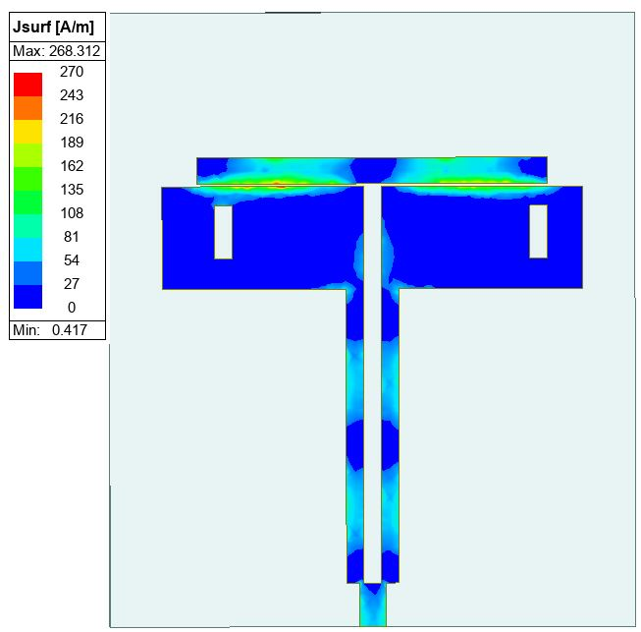

(b)

Fig. 5. Surface current distribution of the patch and the stub for   
a) 3.66 GHz and b) 5.88 GHz.

##### IV. conclusion

The proposed work presents a flexible dual-band microstrip patch antenna with an optically transparent PET substrate on a defected ground structure. The antenna operates between the frequencies of 3.66 GHz and 5.88 GHz with a gain of 5.25 dB at 5.25 GHz, thus making it suitable to work in the IoT and ISM bands and also covering the agreeable amount of bandwidth. The use of PET is characterized by its low-cost production and compactness to achieve optical transparency as well as visual aesthetic of the design. Besides these, PET also offers toughness and high glass transition temperature [9]. Also PET substrate is used for human-body wearable applications due to its low-cost, transparent and flexible features [10]. Nowadays many transparent antennas are being designed and fabricated, leading to new insights into materials and communication engineering [11]. This work can also considered to be another step in exploring the results and effectiveness of transparent antennas using various transparent substrates [12]. Further, more research can be carried out to discover new applications for these type of antennas in the future endeavor.

##### References

1. A. S. MD. Sayem, A. Lalbakhsh, K. P. Esselle, J. L. Buckley, B. O’ Flynn, R. B. V. B. Simorangkir, “Flexible Transparent Antennas: Advancements, Challenges, Prospects,” *IEEE Open Journal of Antennas and Propagation*, vol. 3, pp. 1109-1133, Sept 2022.
2. D. Mollik, R. Islam, A. B. Anwar, P. K. S. Purnendu, M. A. H. Shanto and M. Ahmad, "Design of 24 GHz ISM Band Microstrip Patch Antenna for 5G Communication," *2022 IEEE International IOT, Electronics and Mechatronics Conference (IEMTRONICS)*, Toronto, ON, Canada, 2022, pp. 1-6, doi: 10.1109/IEMTRONICS55184.2022.9795716.
3. E. C. Patil, S. D. Lokhande, U. A. Patil, A. U. Patil, J. Kumar. (2024, January). “Optically transparent dual-band antenna for UHF and S-band applications.” *Optical Materials* [Online]. vol. 147. Available: https://www.sciencedirect.com/science/article/abs/pii/S0925346723011874?via%3Dihub
4. A. Ericsson, “Cellular networks for massive IoT-enabling low-powered wide area applications, Ericsson, Stockholm, Sweden, Rep. UEN 28423-3278, Jan. 2016.
5. J. Kim *et al*., “Wearable smart sensor systems integrated on soft contact lenses for wireless ocular diagnostics,” *Nat. Commun*,. vol. 8, no. 1 Apr. 2017, Art. No. 14997.
6. F. Boccardi, R. W Heath, A. Lozano, T. L. Marzetta and P. Popovski, “Five disruptive technology directions for 5G,” *IEEE Commun. Mag.*, vol. 52, no. 2, pp. 74-80, Feb.2014.
7. J. Kaur, R. Khanna, “Development of Dual-band Microstrip Patch Antenna For WLAN/MIMO/WiMAX/AMSAT/WAVE Applications”. *Microwave and Optical Technology Letters* [Online]. vol. 56, no. 4. DOI 10.1002/mop
8. J. Kaur, R. Khanna, “Development of Dual-band Microstrip Patch Antenna For WLAN/MIMO/WIMAX/AMSAT/WAVE Applications”. *Microwave and Optical Technology Letters* [Online]. vol. 56, no. 4. DOI 10.1002/mop
9. M. S. V. Ferreira, S. H. Mousavi. (2018, April). “Nanofiber technology in the ex vivo expansion of cord blood-derived hematopoietic stem cells”. *Nanomedicine: Nanotechnology, Biology, and Medicine* [Online]. vol. 14, issue 5, pp. 1707-1718. Available: https://doi.org/10.1016/j.nano.2018.04.017
10. K. Upreti, "A Flexible Wearable Antenna for Wireless Body Area Network Application," 2021 IEEE Indian Conference on Antennas and Propagation (InCAP), Jaipur, Rajasthan, India, India, 2021, pp. 163-166, doi: 10.1109/InCAP52216.2021.9726475.
11. Z. J. Silva, C. R. Valenta and G. D. Durgin, "Optically Transparent Antennas: A Survey of Transparent Microwave Conductor Performance and Applications," in IEEE Antennas and Propagation Magazine, vol. 63, no. 1, pp. 27-39, Feb. 2021, doi: 10.1109/MAP.2020.2988526.
12. O. R. Alobaidi, P. Chelvanathan, S. K. Tiong, B. Bais, MD. A. Uzzaman, N. Amin. (2022, February). “Transparent Antenna for Green Communication Feature: A Systematic Review on Taxonomy Analysis, Open Challenges, Motivations, Future Directions and Recommendations”. *IEEE Access* [Online]. vol. 10, pp. 12286-1232. DOI: 10.1109/ACCESS.2020.3044435.